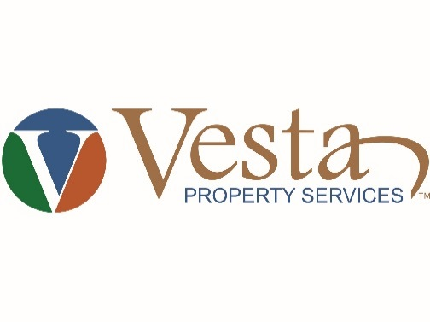

12250 Tamiami Trail East, Suite 207
Naples, FL 34113
239-747-7227, f 239-919-3178
dkosmala@vestapropertyservices.com
www.VestaPropertyServices.com

Windsor PLACE AT BERKSHIRE LAKES
Condominium Association, Inc.

Board of Directors and Budget Adoption
Meeting Notice

DATE: Wednesday, November 11, 2020
TIME: 7:00 p.m.
LOCATION: Conference
Call-In Number: 866-705-2554
Listen-In Passcode: 4841597
Any questions for the meeting please email dkosmala@vestapropertysevices.com or text to 239-728-1303 prior to or during the meeting. They will be reviewed at the end of the meeting.

AGENDA

- Call to order and determination of Quorum

- Proof of Notice

- Disposal of the Previous Meeting Minutes

- President’s Report

- Vice President Report

- Directors Reports

- Treasurer’s Report

- Manager’s Report

- Committee Reports:

- Leases and Sales

- Old Business:

- New Business:
  - Mulch
  - Tree Trimming
  - Approve 2021 Annual Budget

- Open Forum

- Adjournment

