Windsor Place Condominium Association
in Berkshire Lakes
Naples, Florida 34104
Date: July 20, 2020
Attention: Unit Owners, Lessee’s, and Guest,

Windsor is about to start a two-week maintenance project, July 27 – August 10, 2020, with Baine’s, “Seal Coating”. We will be seal coating our roads and guest parking areas. This is a project in which we MUST have your total cooperation.
Below is a site map for Windsor. Attached is the same site map, larger and more legible, for the Windsor property, which has been nicely color coded and date orientated for the areas that will be impacted. Each area of seal coating is a two-day process.
When seal coating is taking place in your area you will need to seek alternative parking, which could be close by or perhaps some distance away. In order, not to track wet tar onto your driveway and into your condo walking on grassed areas may become necessary.
We will make every effort possible to make this project move smoothly. For the two-week period we will NOT be mowing and blowing. Some irrigation restrictions will be incorporated during this process and Waste Management will NOT service Windsor during the week. Saturday only and it will require your assistance placing your barrels in the appropriate areas for pick up.
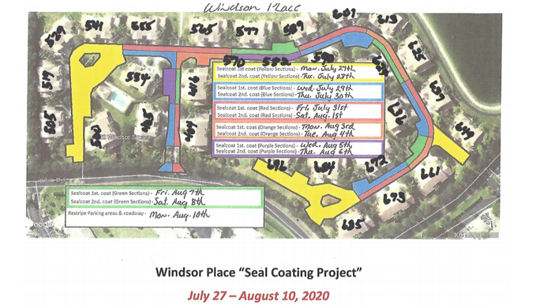
The final day of the project will be to Restripe Parking areas & Roadway.
Thanks in advance for your help, patience, and cooperation.
The end results will be worth the efforts.
